**11. Change Hardware compatibility of a VM (Either by clone/create new one) which is already created and configured.**

STEP1:

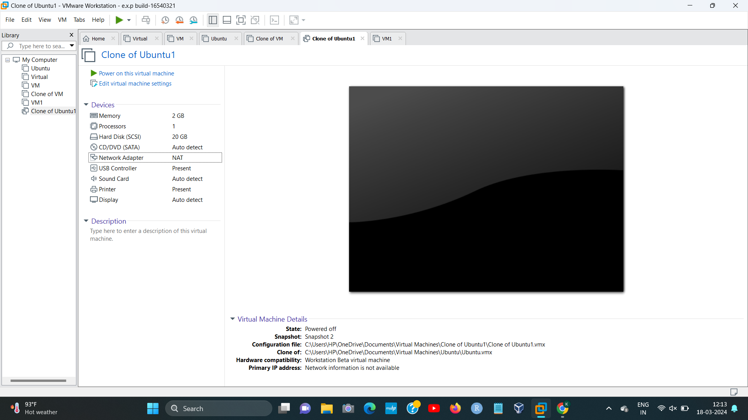

STEP2:

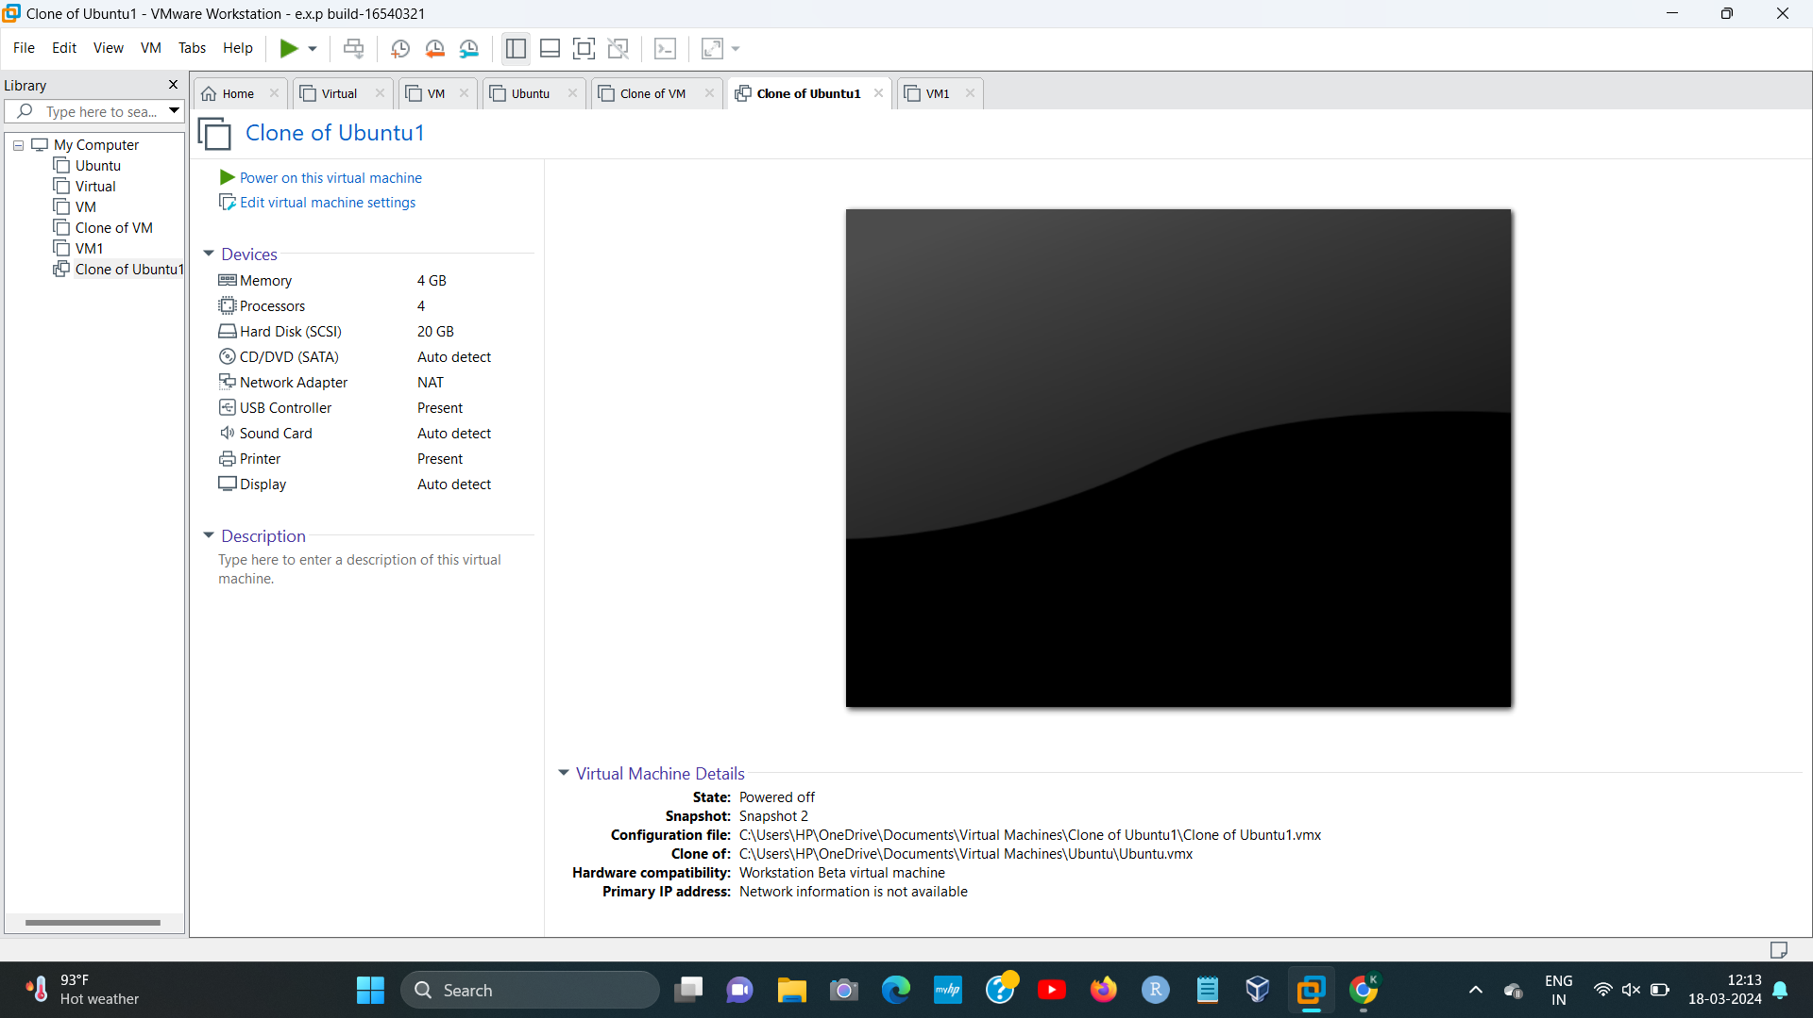[1]

1. 192224191 L.KALYANI